**11. Kubernetes ReplicaSet - Review manifests and Create ReplicaSet**

--- **Reference** - <https://github.com/stacksimplify/kubernetes-fundamentals/tree/master/03-ReplicaSets-with-kubectl\>

--- **note** - we don’t have an imperative command to create a replicaset. So, we need to use declarative way.

**Create ReplicaSet**

--- **cat replicaset-demo.yml**

apiVersion: apps/v1

kind: ReplicaSet

metadata:

  name: my-helloworld-rs

  labels:

    app: my-helloworld

spec:

  replicas: 3

  selector:

    matchLabels:

      app: my-helloworld

  template:

    metadata:

      labels:

        app: my-helloworld

    spec:

      containers:

      - name: my-helloworld-app

        image: stacksimplify/kube-helloworld:1.0.

--- **my-helloworld-rs** - replicaset name.

metadata:

  name: my-helloworld-rs

--- **relicas: 3** – no of pods you want to create.

spec:

  replicas: 3

--- **my-helloworld-app** – my container name.

--- **stacksimplify/kube-helloworld:1.0**. – it is my image name.

spec:

      containers:

      - name: my-helloworld-app

        image: stacksimplify/kube-helloworld:1.0.

--- **kubectl create -f replicaset-demo.yml** – for creating replicaset.

**List ReplicaSets**

--- **kubectl get replicaset** – list the replicaset.

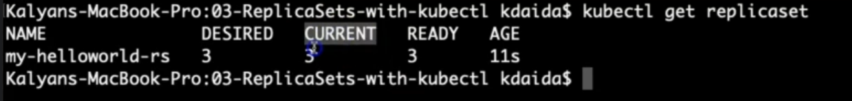

--- **note** – here you can see that the desired pods is 3 and currently running pods is 3 and the age is 11s.

--- **kubectl get rs** – it is alias name or shortcut name. you can use this command, instead of above command.

**Describe ReplicaSet**

--- **kubectl describe rs/<replicaset-name>** - Describe the newly created ReplicaSet

--- **kubectl describe rs/my-helloworld-rs**

**[or]**

**kubectl describe rs my-helloworld-rs**

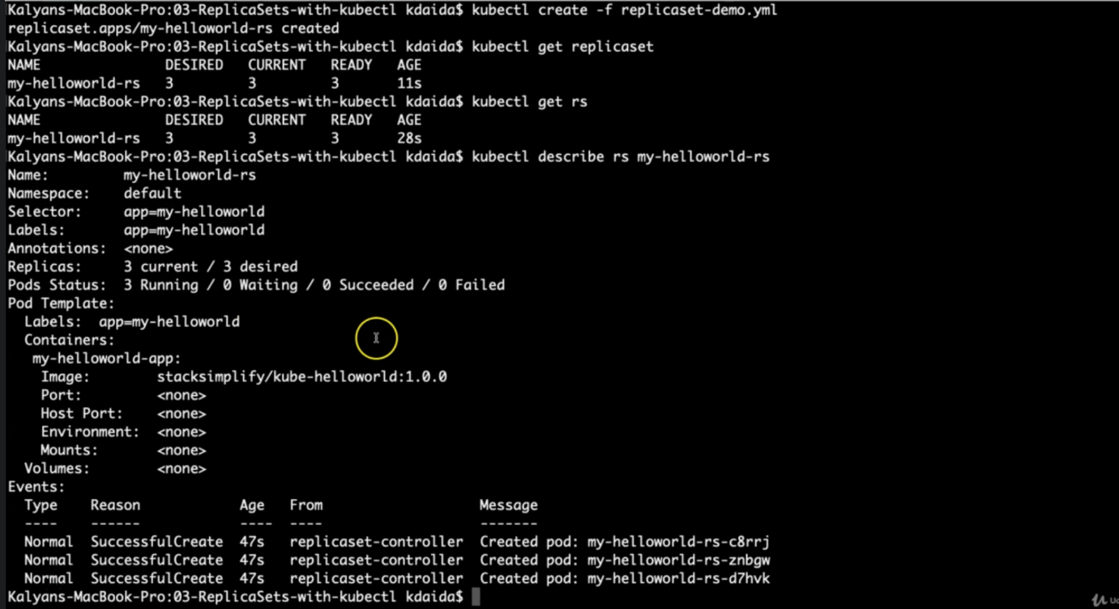

--- **note** – it is created 3 pods here and it does not have the issue in crating these 3 pods.

**Get list of Pods**

**#Get list of Pods**

--- **kubectl get pods**

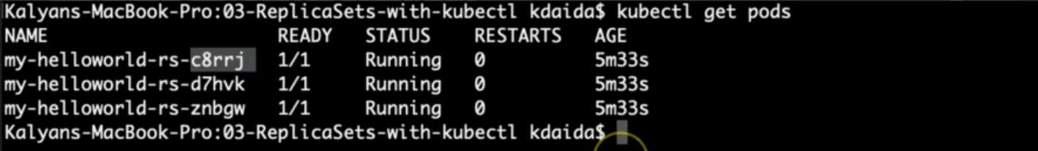

--- **kubectl describe pod <pod-name>**

**# Get list of Pods with Pod IP and Node in which it is running**

--- **kubectl get pods -o wide**

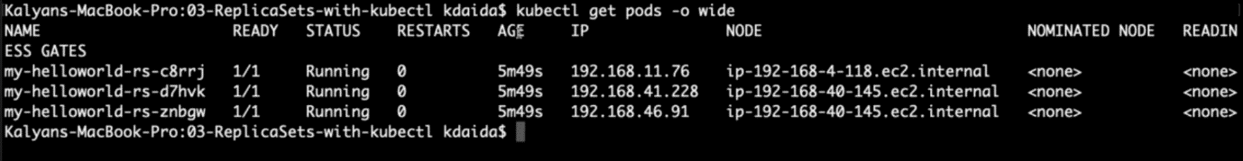

**Verify the Owner of the Pod**

--- **Verify the owner reference of the pod** - Verify under "name" tag under "ownerReferences". We will find the replicaset name to which this pod belongs to.

--- **kubectl get pods <pod-name> -o yaml**

--- **kubectl get pods my-helloworld-rs-c8rrj -o yaml**

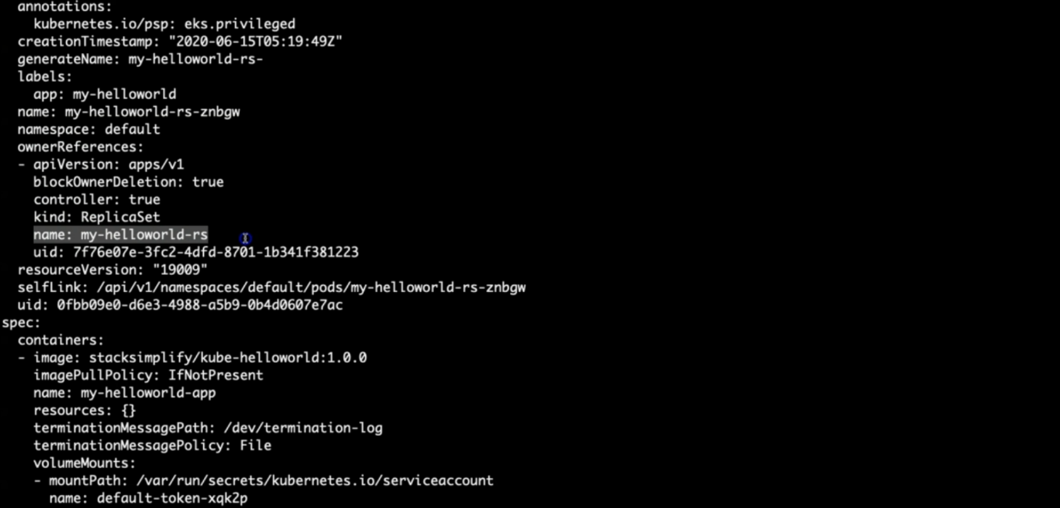

--- **note** – it belongs to my-helloworld-rs replicaset.